Quantum-Secure Fraud Detection System: An Empirical Study of Quantum Machine Learning, Post-Quantum Cryptography, and Risk-Adaptive Financial Security
Shreyansh Jaiswal, Abhishek Chaubey, Debshata Choudhury
Department of Computer Science & Engineering, Amity School of Engineering & Technology, Amity University, India
jaiswal.shreyansh.official@gmail.com, abhishekchaubey501@gmail.com, debshatachoudhury@gmail.com
Abstract
This study investigates where quantum machine learning (QML), post-quantum cryptography (PQC), and simulated quantum key distribution (QKD) provide measurable value within an integrated, fraud-aware financial security architecture -- and where they do not. Rather than assuming quantum methods must outperform classical alternatives, controlled experiments with strong classical controls and pre-specified protocols are used to identify both benefits and boundaries. In Layer 1, a 20-seed paired experiment shows that changing a variational quantum circuit's measurement observable from a global to a local-sum formulation produces a statistically significant improvement in fraud-ranking performance (bootstrap 95% CI excludes zero, Wilcoxon p=0.0086, permutation p=0.0072); a subsequent classical capacity-control experiment shows this improvement does not extend to a verified system-level predictive advantage over the production XGBoost classifier. In Layer 2, classical cryptography (AES-256-GCM, RSA-3072, ECC/P-256), standardized post-quantum cryptography (ML-KEM-768, ML-DSA-65, SLH-DSA-SHA2-128s), and a BB84 QKD simulation are implemented and benchmarked. A pre-specified integration experiment connects the two layers through an auditable SecurityContext and finds that neither anomaly-assisted nor quantum-assisted security-routing signals clear a pre-committed cost budget on the tested data. No quantum advantage is claimed; negative and null results are reported with the same rigor as positive ones, and the study's principal architectural conclusion is that fraud risk and cryptographic-quantum-threat posture must be modeled as separate axes.
Keywords— fraud detection, quantum machine learning, post-quantum cryptography, BB84, risk-adaptive security, XGBoost, variational quantum circuits, observable locality
- Introduction
Financial transaction security faces two related but distinct challenges: behavioral fraud and the future vulnerability of public-key cryptography to quantum computers. This study motivates and investigates three related but distinct research dimensions: (A) whether quantum model design can improve a variational quantum fraud classifier's stability and predictive behavior; (B) whether such an improvement translates into predictive superiority over strong classical methods; and (C) how fraud intelligence, post-quantum cryptography, and simulated quantum key distribution can coexist within a single risk-adaptive architecture, and what trade-offs result.
A central conceptual distinction motivates the system architecture: fraud risk ("how suspicious is this transaction?") is not equivalent to cryptographic quantum risk ("what protection should this transaction receive under the system's security policy?"). A transaction with low fraud probability is not thereby exempt from post-quantum protection, and a transaction with high fraud probability is not automatically more vulnerable to Shor's algorithm. This distinction, and the experiments that motivate it, are developed throughout this report.
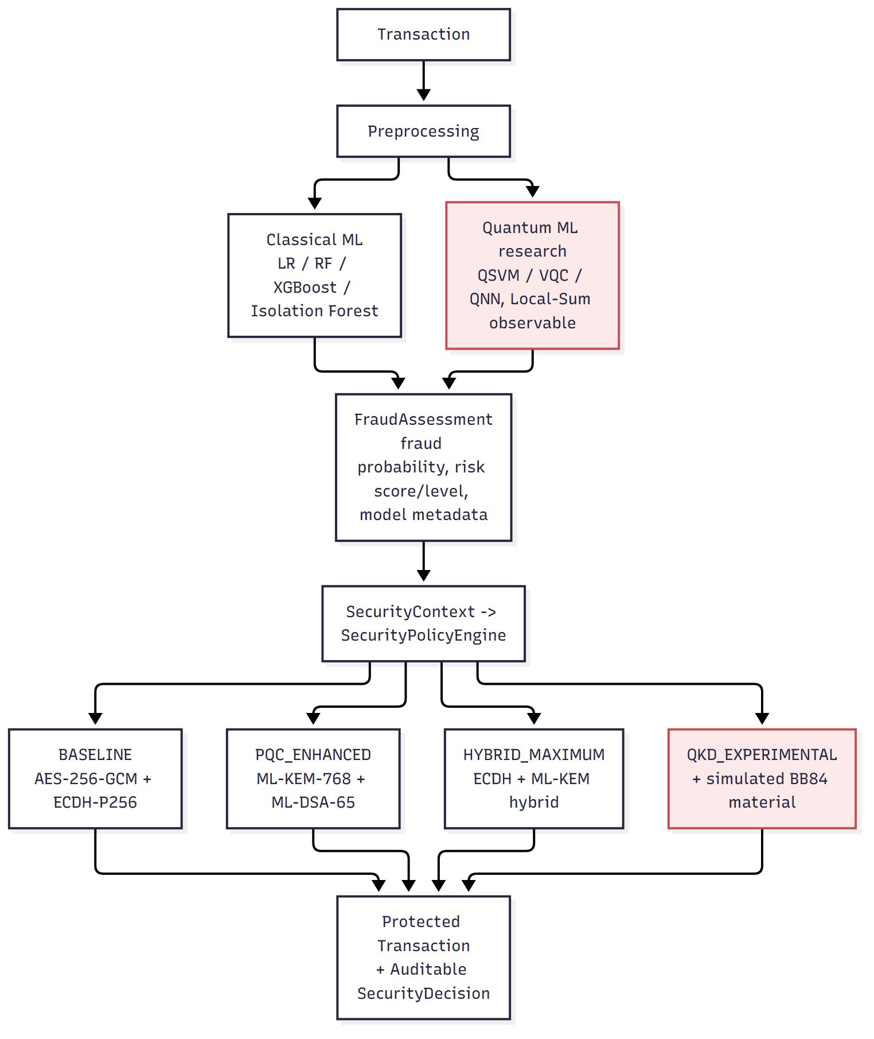
Fig. 1. Overall QSFD architecture. Every security profile, including BASELINE, applies full AES-256-GCM authenticated encryption plus a real key-establishment algorithm; fraud risk controls only additional protection layered on top.
- Research Gap
Much existing work evaluates QML fraud detection, PQC, or QKD as separate technical problems. This study evaluates how these components behave when placed in a shared, risk-aware financial-security architecture, while subjecting the QML component to strong classical controls and formal statistical validation -- a combination not claimed here as unprecedented, but as methodologically distinguishing.
- Literature Review
Six research sources were read in full and used to motivate specific experiments rather than being reproduced wholesale. Cerezo et al. [3] proved that global measurement observables cause harder-to-train quantum circuits even at shallow depth; this directly motivated the central Layer 1 finding reported in Section V. Kyriienko and Magnusson [4] proposed an unsupervised quantum-kernel anomaly detector on the identical Kaggle credit-card-fraud dataset used in this study; the corresponding experiment here found the approach did not replicate at scale. Data re-uploading [1] and barren-plateau initialization [2] were each tested as adapted experiments and did not improve on the existing baselines. NIST's FIPS 203/204/205 standards [6-8] define the post-quantum algorithms implemented in Layer 2, and Bennett and Brassard's original protocol description [9] is the basis for the Layer 2 BB84 simulation. One supplied reference document could not be read (a scanned, image-only PDF with no extractable text); its content is not guessed anywhere in this study.
- Methodology
Layer 1 uses the Kaggle creditcardfraud dataset (284,807 transactions, 0.173% fraud) with a temporal train/validation/test split, duplicate removal prior to splitting, and preprocessing fit exclusively on the training fold. Four classical models were evaluated; XGBoost was selected for production owing to substantially lower latency at a statistically indistinguishable predictive difference from Random Forest. A quantum research branch evaluated QSVM, VQC, and QNN architectures on a locked, rebalanced controlled subset, culminating in a 20-seed paired experiment (identical initialization per seed across both arms) comparing a global-observable QNN against a local-sum-observable QNN, validated with paired bootstrap, Wilcoxon signed-rank, and permutation tests, then cross-checked against a matched classical nonlinear capacity control.
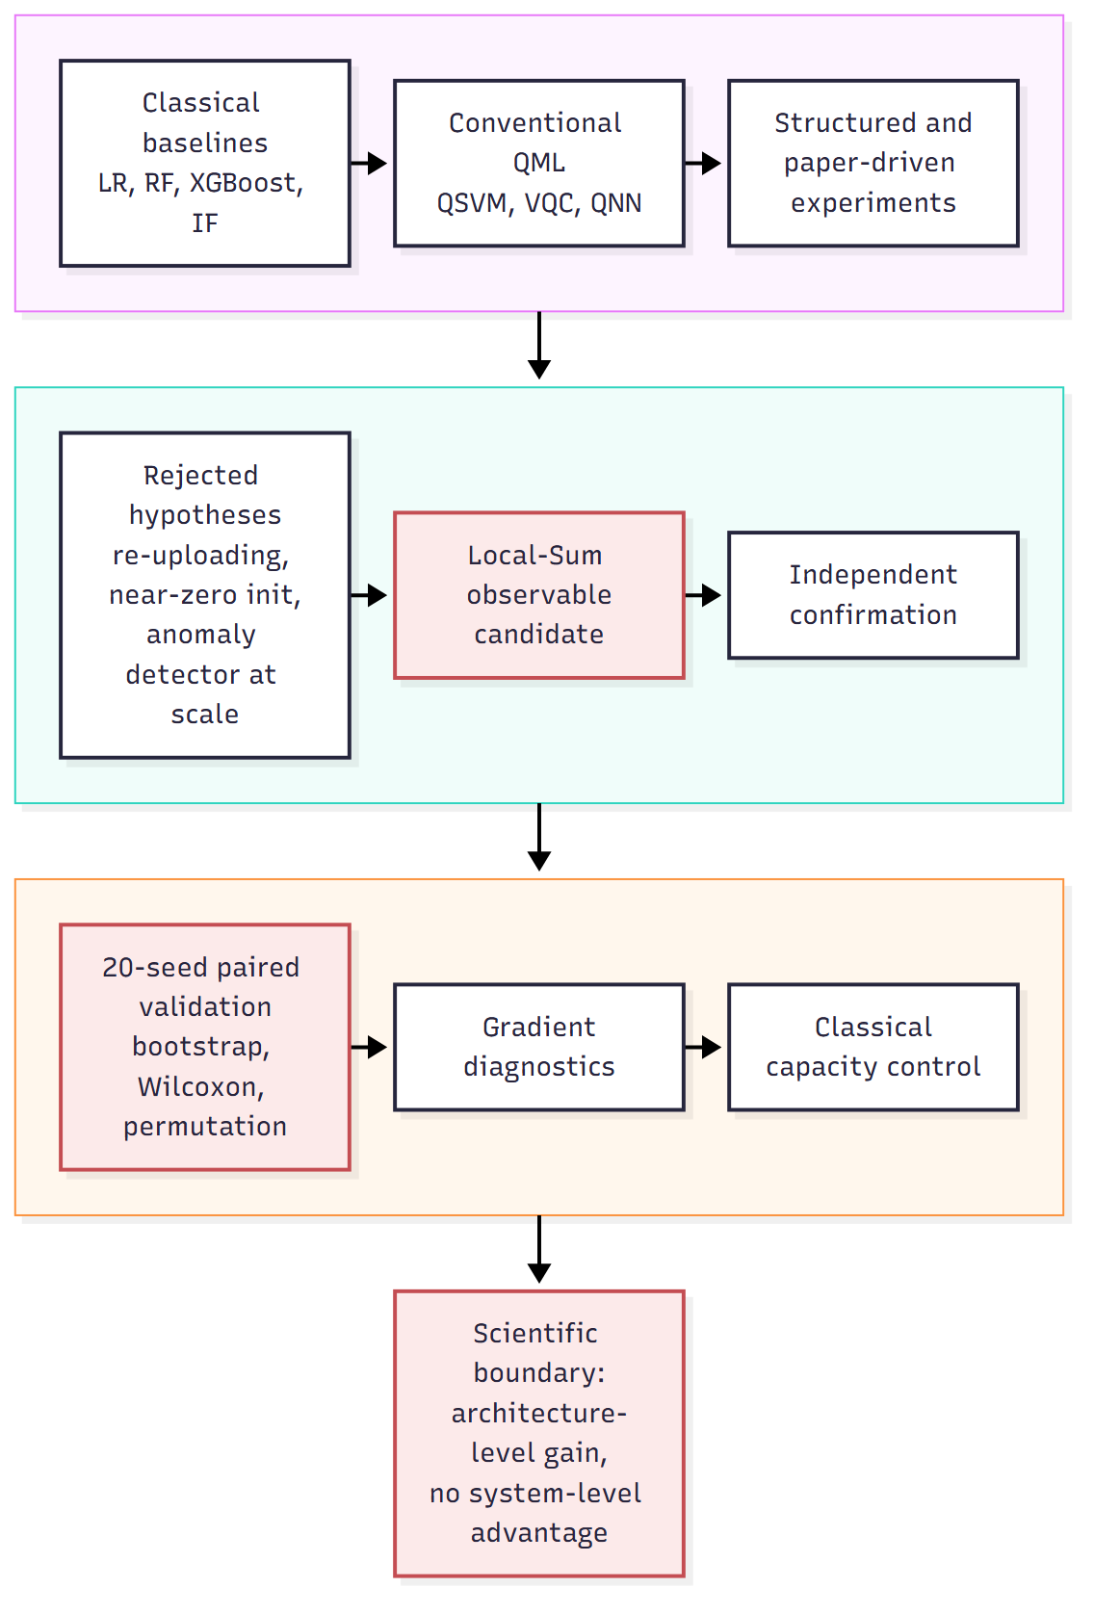
Fig. 2. Layer 1 experimental workflow. Each stage exists to test a specific hypothesis; rejected hypotheses (re-uploading, near-zero initialization, the anomaly detector at scale) narrowed the research question toward the Local-Sum observable candidate.
Layer 2 implements AES-256-GCM, RSA-3072, and ECC/P-256 via the `cryptography` package, and ML-KEM-768, ML-DSA-65, and SLH-DSA-SHA2-128s via pure-Python reference implementations (native liboqs could not be built without a C toolchain in the development environment). All cryptographic operations were benchmarked with 30 repetitions (reduced to 5 for SLH-DSA signing given its substantial per-call cost). BB84 was implemented as a classical simulation of the protocol's sifting and quantum-bit-error-rate estimation procedure, evaluated across 30 trials per tested condition. The Layer 1-to-Layer 2 integration experiment's policy formulations, data samples, metrics, and selection criterion were committed to a written protocol before the experiment was executed.
- Layer 1: Fraud Detection Methodology and Equations
For imbalanced classification, the primary evaluation metric is PR-AUC rather than accuracy or ROC-AUC, computed from:
Precision = TP / (TP + FP) Recall = TP / (TP + FN) (1)
F1 = 2 * Precision * Recall / (Precision + Recall) (2)
The quantum models encode a classical feature vector into a parameterized quantum state and read out an expectation value:
|psi(x,theta)> = V(theta) . U_enc(x) |0>^(xn) (3)
f_theta(x) = <psi(x,theta)| O |psi(x,theta)> (4)
where O is the measured observable. The project's existing QNN implicitly used a global observable (the qiskit-machine-learning default):
O_global = Z_0 (x) Z_1 (x) ... (x) Z_(n-1) (5)
The tested alternative, motivated by Cerezo et al. [3], is a local-sum observable:
O_local-sum = (1/n) * sum_{i=0}^{n-1} Z_i (6)
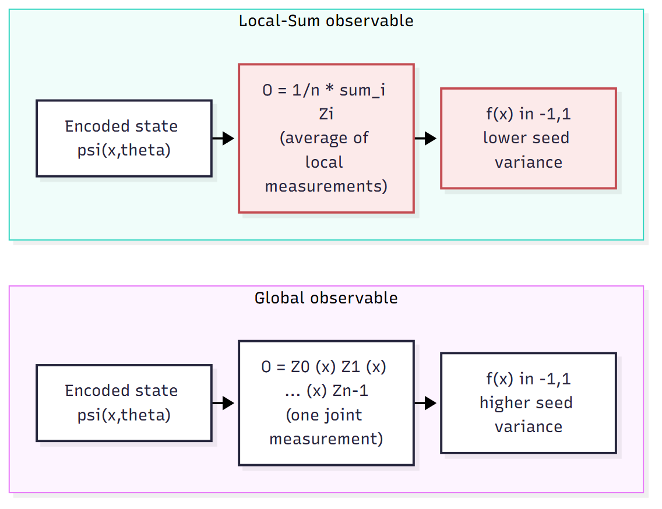
Fig. 3. Global vs. local-sum measurement strategy on an identical circuit -- only the measured observable differs between the two arms of the paired experiment.
The paired per-seed improvement and its mean across 20 seeds are:
Delta_i = PR-AUC_LocalSum,i - PR-AUC_Global,i, i = 1..20 (7)
Delta_bar = (1/20) * sum_i Delta_i (8)
with uncertainty estimated by a 5000-resample bootstrap over the 20 seeds, and significance assessed with a one-sided Wilcoxon signed-rank test and a sign-flip permutation test.
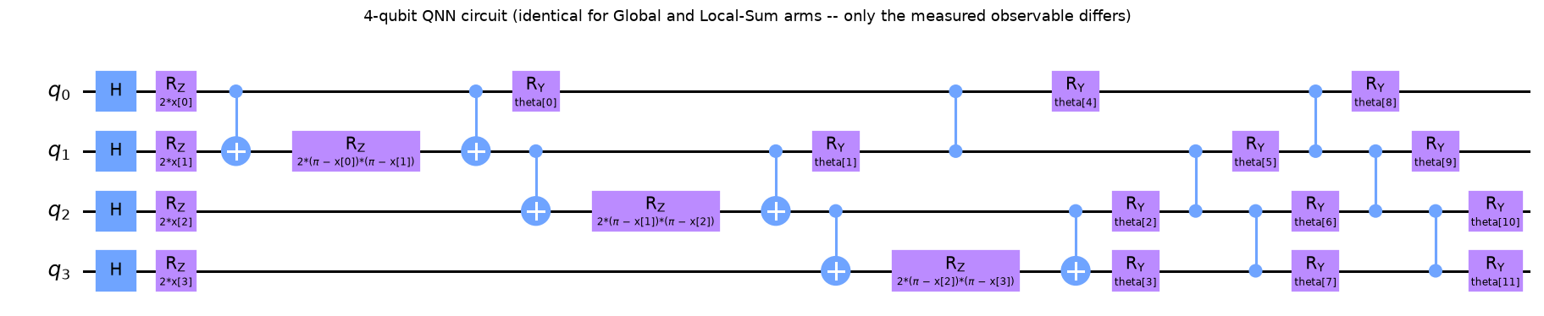
Fig. 4. Global-observable QNN circuit as actually implemented (4 qubits, linear entangling topology, ZZ-style feature encoding followed by a RealAmplitudes-style ansatz).
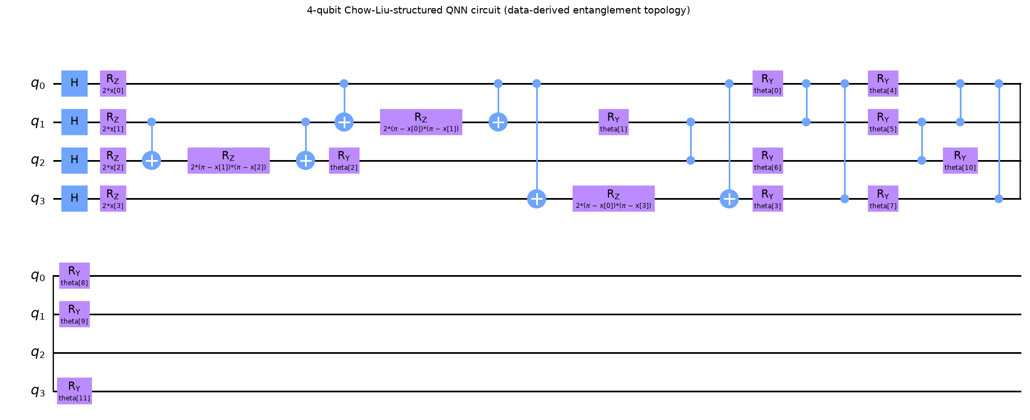
Fig. 5. Chow-Liu-structured QNN circuit -- entanglement pairs determined by mutual-information structure learned from the training data, rather than a generic topology.
- Layer 1: Results
TABLE I
Classical Model Comparison (Model, PR-AUC, ROC-AUC, Precision, Recall)
model | pr_auc | roc_auc | precision | recall
random_forest | 0.8190 | 0.9691 | 0.9032 | 0.7567
xgboost | 0.8007 | 0.9771 | 0.9016 | 0.7432
logistic_regression | 0.7327 | 0.9838 | 0.7727 | 0.6891
isolation_forest | 0.0396 | 0.9492 | 0.0444 | 0.5810
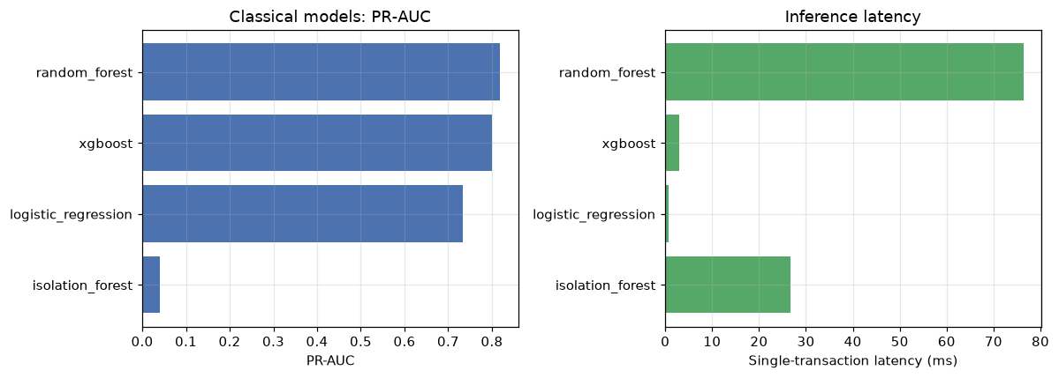
Fig. 6. PR-AUC and single-transaction latency across all four classical models. XGBoost is selected for production for its latency advantage, not the highest point-estimate PR-AUC.
The decisive quantum-architecture experiment compared a global-observable QNN (mean PR-AUC 0.8077, standard deviation 0.073 across 20 seeds) against a local-sum-observable QNN (mean PR-AUC 0.8612, standard deviation 0.051) on an independent, previously-unseen confirmation split.
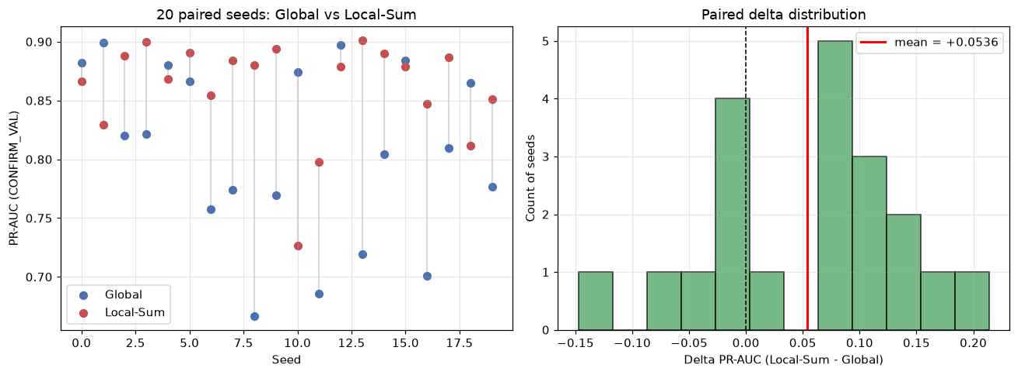
Fig. 7. Paired PR-AUC comparison between the Global-observable and Local-Sum QNN across 20 matched random seeds (left) and the resulting delta distribution (right). The Local-Sum configuration achieves a positive mean paired difference in 13 of 20 seeds.
TABLE II
Paired Statistical Validation, Global vs. Local-Sum QNN
Statistic | Value
Mean paired delta | +0.0536
Bootstrap 95% CI | [+0.0149, +0.0913]
Wilcoxon p (one-sided) | 0.0086
Permutation p (one-sided) | 0.0072
Seed wins (Local-Sum) | 13 / 20
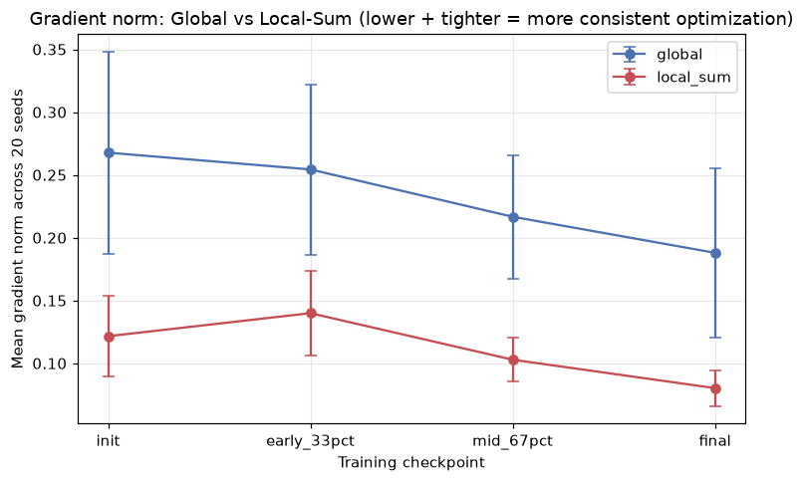
Fig. 8. Gradient norm by training checkpoint, Global vs. Local-Sum observable. The Local-Sum observable shows consistently smaller and less variable gradients -- consistent with improved optimization stability, not with a change in gradient magnitude indicating barren-plateau elimination.
This architecture-level result was then tested for system-level relevance against a matched classical nonlinear capacity control.
TABLE III
Classical Capacity Control (Locked Confirmation Split)
Architecture | PR-AUC
XGBoost alone | 0.9613
XGBoost + Local-Sum QNN | 0.9665
XGBoost + matched classical control | 0.9671
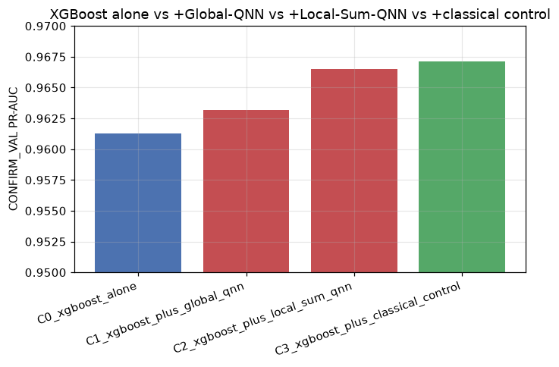
Fig. 9. XGBoost alone vs. +Global-QNN vs. +Local-Sum-QNN vs. +matched classical control. The classical control's point estimate exceeds the quantum-augmented ensemble's; this figure establishes the boundary of the Local-Sum finding.
The classical control's point estimate (0.9671) exceeds the quantum-augmented ensemble's (0.9665), and neither the quantum-augmented ensemble's improvement over XGBoost alone (95% bootstrap CI [-0.0035, +0.0173]) nor its comparison against the classical control excludes zero. Every other quantum architecture evaluated in this study -- QSVM, VQC, Chow-Liu-structured circuits, QBoost, five hybrid fusion architectures, and a quantum-kernel anomaly detector -- likewise failed to establish a statistically supported predictive advantage over its classical counterpart; the anomaly detector's promising small-scale result did not replicate at a larger, independent scale.
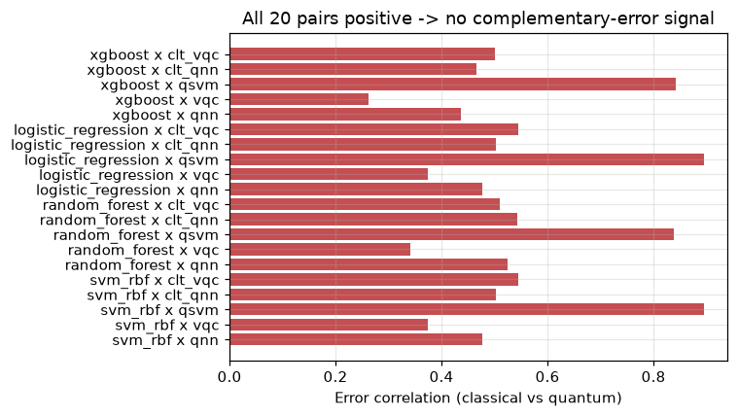
Fig. 10. Classical x quantum error correlation across all 20 tested pairs -- every pair is positively correlated, providing no basis for a complementary-error ensemble benefit.
- Layer 2: Results
Post-quantum key establishment follows the standard KEM interface:
(pk, sk) <- KeyGen(); (c, K) <- Encaps(pk); K' <- Decaps(sk, c); K = K' (9)
Digital signatures (classical and post-quantum) follow:
sigma <- Sign(sk, m); Verify(pk, m, sigma) in {true, false} (10)
The hybrid key-derivation construction used for HYBRID_MAXIMUM/QKD_EXPERIMENTAL is:
K = HKDF-SHA256( ECDH_secret || ML-KEM_secret ) (11)
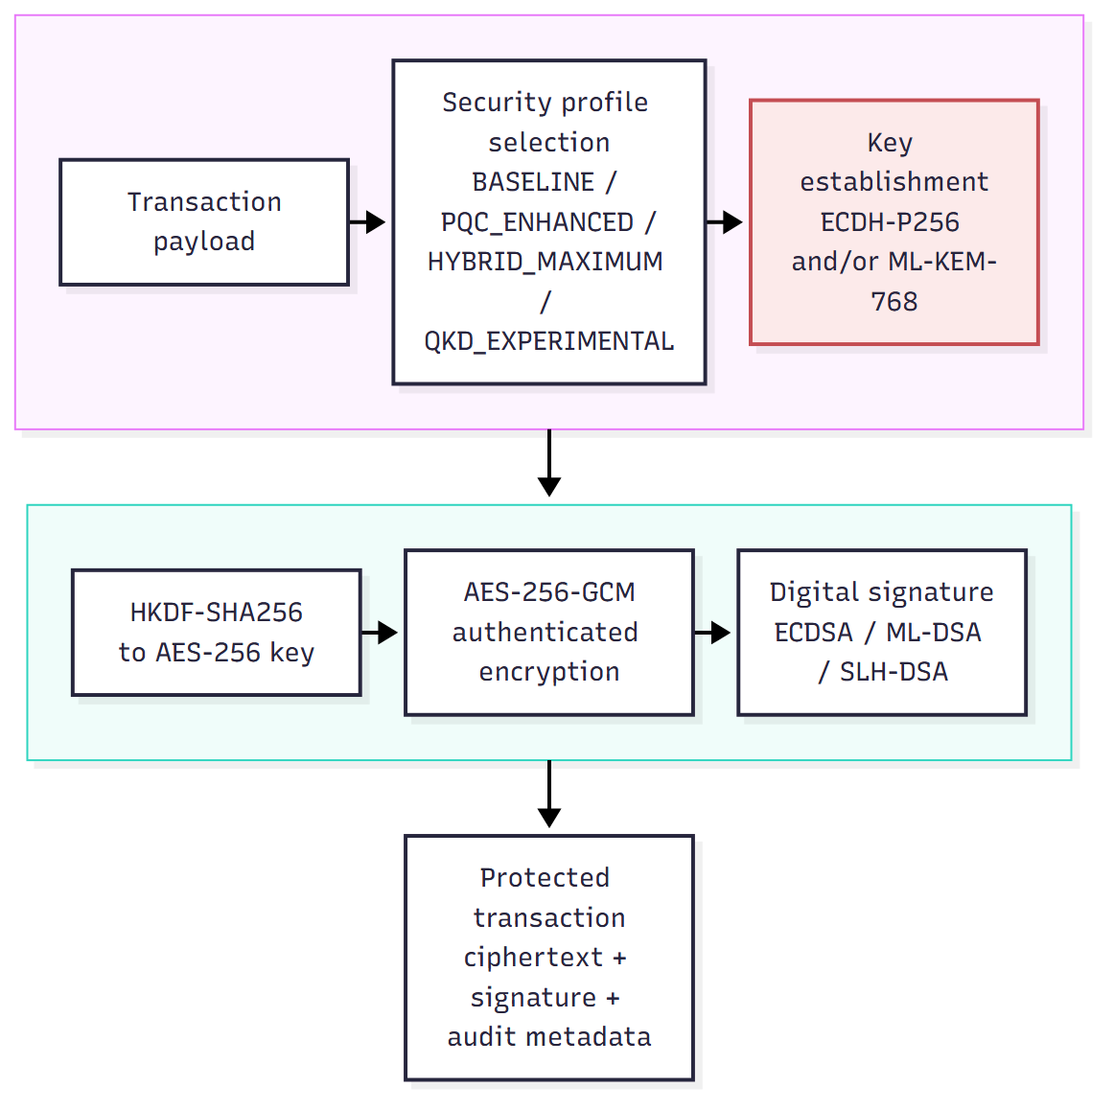
Fig. 11. Layer 2 cryptographic protection workflow. ML-KEM establishes a key; AES-256-GCM always performs the bulk symmetric encryption of the payload.
TABLE IV
Signature Sizes by Algorithm (bytes)
Algorithm | Size (bytes)
RSA-3072-PSS | 384
ECDSA-P256 | 70
ML-DSA-65 | 3309
SLH-DSA-SHA2-128s | 7856
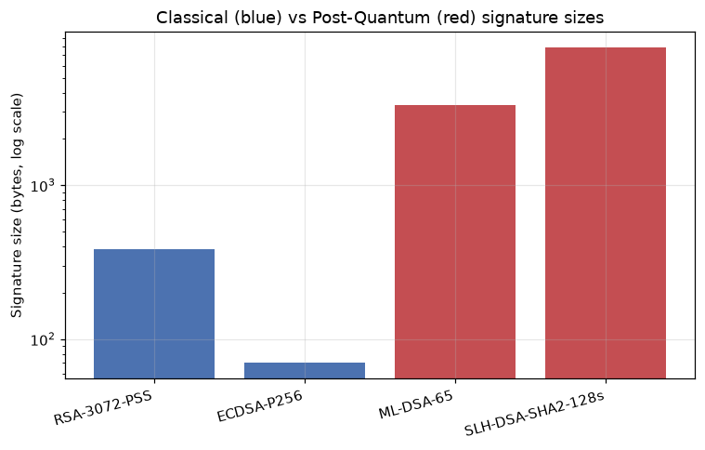
Fig. 12. Classical vs. post-quantum signature sizes (log scale). ML-DSA-65 is approximately 47x ECDSA's size; SLH-DSA-SHA2-128s is approximately 112x.
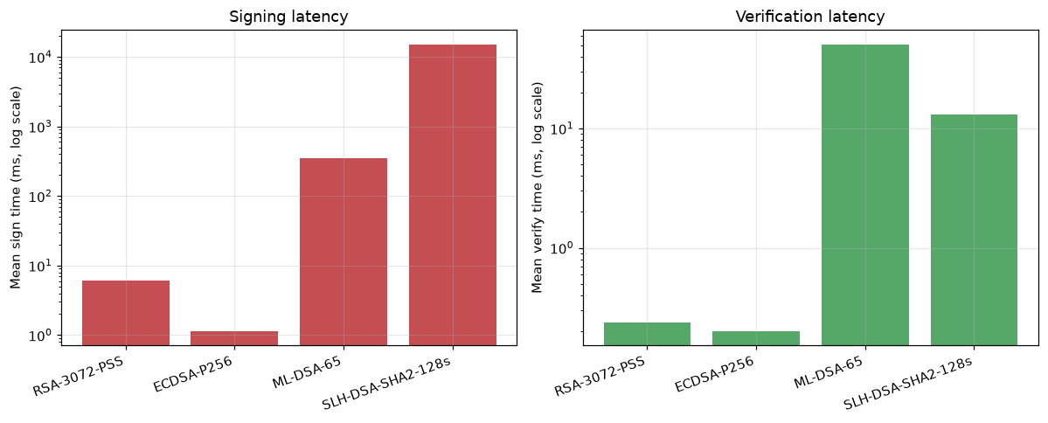
Fig. 13. Sign (left) and verify (right) latency by algorithm, log scale. The large SLH-DSA latency is left visible rather than compressed by axis scaling.
ML-DSA-65 signing exhibited a genuinely large runtime variance (86 to 1494 milliseconds across 30 repetitions), attributable to the scheme's Fiat-Shamir-with-aborts rejection sampling rather than measurement noise. SLH-DSA signing required approximately 15 seconds per call in this pure-Python implementation, making the evaluated configuration unsuitable for this study's real-time transaction path; this is a property of this specific implementation and parameter set, not a general claim about SLH-DSA or about optimized native implementations.
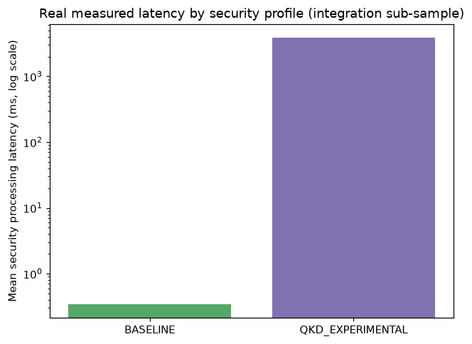
Fig. 14. Real measured end-to-end latency by security profile. HYBRID_MAXIMUM/QKD_EXPERIMENTAL cost is dominated by SLH-DSA signing.
- BB84 Quantum Key Distribution Simulation
|0>, |1> (computational basis) (12)
|+> = (|0> + |1>) / sqrt(2), |-> = (|0> - |1>) / sqrt(2) (Hadamard basis) (13)
QBER = N_error / N_sifted (14)
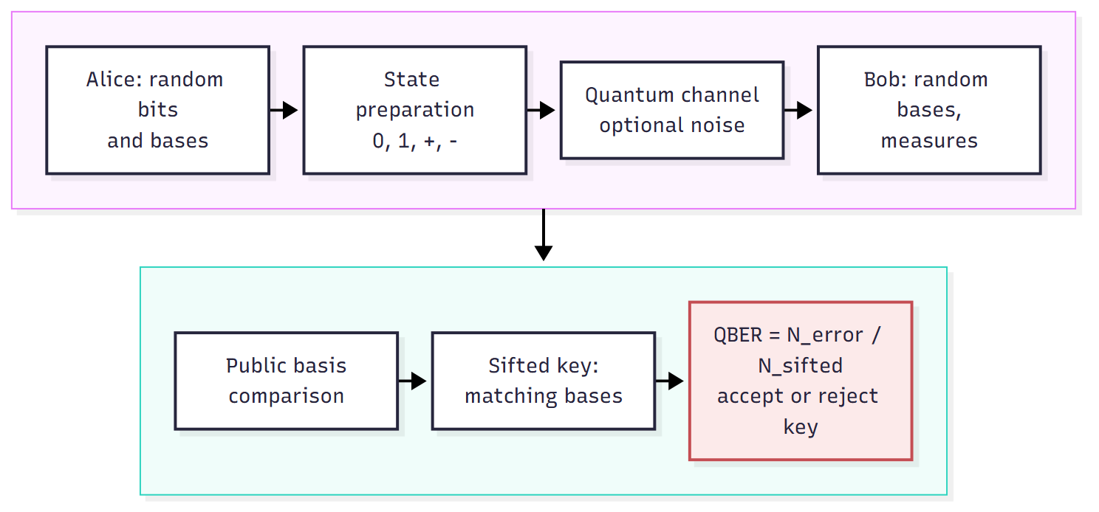
Fig. 15. BB84 protocol as simulated in this study -- a classical software simulation of the protocol's information-theoretic structure, not a physical quantum channel.
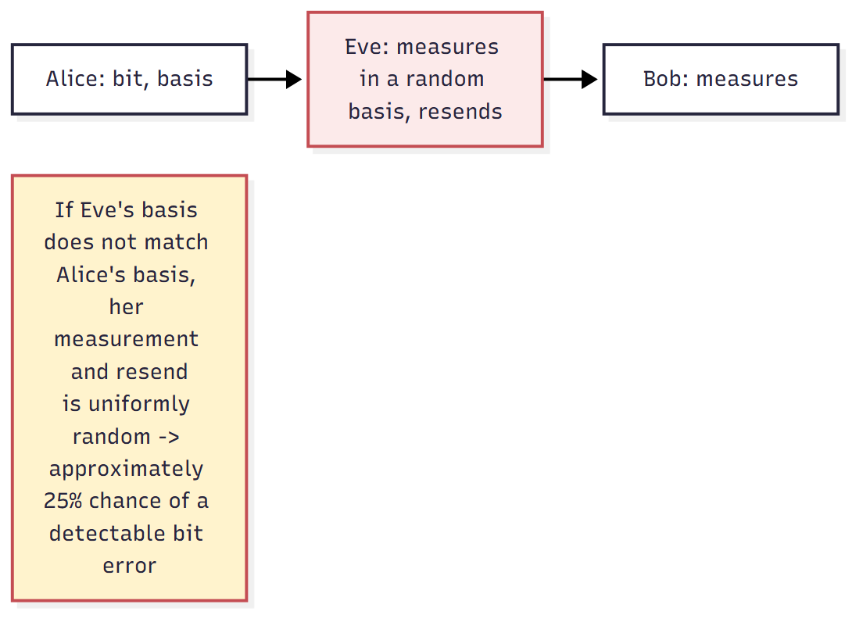
Fig. 16. Intercept-resend eavesdropping: when Eve's basis does not match Alice's, her measurement and resend is uniformly random, introducing a detectable bit error with probability approximately 25%.
TABLE V
BB84 Simulation Results (30 Trials per Condition)
condition | n_trials | key_acceptance_rate
clean | 30 | 1.0
noise_1pct | 30 | 1.0
noise_5pct | 30 | 1.0
noise_10pct | 30 | 0.8
eve_intercept_resend | 30 | 0.0
eve_and_noise_2pct | 30 | 0.0
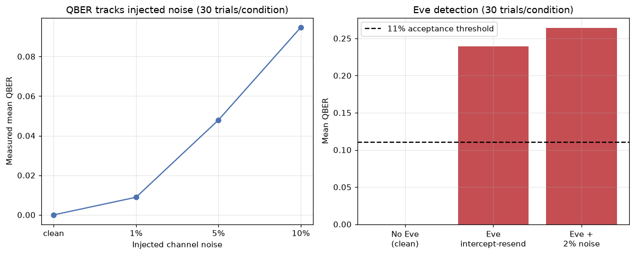
Fig. 17. Measured QBER vs. injected channel noise (left) and Eve detection (right), 30 trials per condition. QBER tracks injected noise closely; the intercept-resend eavesdropper was detected in all 30 trials at the stated 11% threshold.
Measured quantum bit error rate tracked injected channel noise closely across all tested conditions (1% noise -> 0.89% measured QBER; 5% -> 4.79%; 10% -> 9.47%), and an intercept-resend eavesdropper was detected in all 30 trials at the standard 11% acceptance threshold, with measured error rates near the textbook-predicted 25% for this attack. This result is valid under exactly these 30-trial, 2000-bit conditions and is not generalized to a universal eavesdropper-detection guarantee.
- Implementation Backend as a Source of PQC Performance Variation
The pure-Python PQC latencies above, especially SLH-DSA's, are poor proxies for an optimized native implementation's cost. To quantify this, a native PQC backend (`liboqs-python`, wrapping the native `liboqs` C library) was attempted as a bounded follow-up experiment. The Python package installed successfully, but importing it triggers an automatic native-library build via CMake, which failed immediately because this Windows development environment has no CMake or MSVC C/C++ toolchain on its PATH and no unattended toolchain installation route was available. Per the pre-specified fallback rule for this experiment, no substitute cryptographic package was installed merely for having a similarly named algorithm. Result: native PQC backend unavailable in the current environment. Consequently, no native-liboqs benchmark exists. The reference-vs-compiled comparison was instead carried out with the pqcrypto package (see the Final Layer 2 Experiments chapter below), and the SLH-DSA signing time reported above is a reference-Python-implementation cost, not an implementation-independent property. This attempt, and its outcome, are reported rather than omitted.
- Qiskit Circuit-Level BB84 Cross-Validation
The BB84 simulation above operates at the protocol level, sampling sifting and error outcomes from modeled probabilities. As an independent cross-validation, a second, circuit-level BB84 implementation was built using Qiskit and Qiskit Aer (qiskit 2.5.2, qiskit-aer 0.17.2), which prepares and measures explicit single-qubit states rather than sampling protocol-level probabilities directly.
bit=0,Z -> |0> (I); bit=1,Z -> |1> (X) (18)
bit=0,X -> |+> (H); bit=1,X -> |-> (X then H) (19)
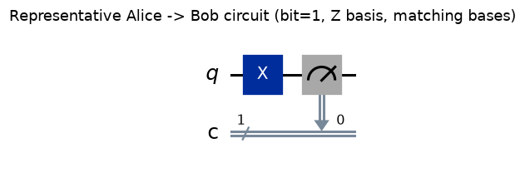
Fig. 18. Representative Alice-to-Bob BB84 circuit (bit=1, Z basis, matching bases): state preparation followed by Bob's computational-basis measurement.
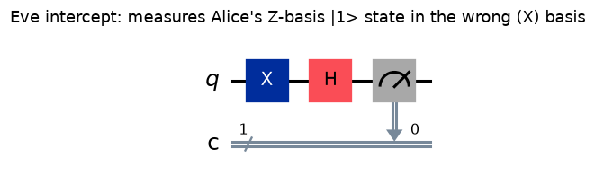
Fig. 19. Representative intercept-resend circuit: Eve measures Alice's Z-basis |1> state in the wrong (X) basis before resending, the mechanism by which an eavesdropper introduces detectable error.
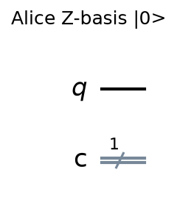
Fig. 20. Alice state preparation, Z basis, bit=0 (|0>, identity).
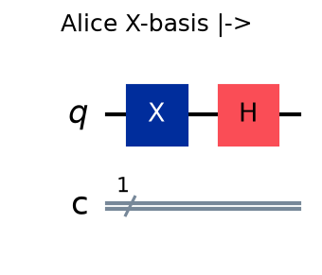
Fig. 21. Alice state preparation, X basis, bit=1 (|->, X then H).
The circuit implementation was run under the same six conditions as the protocol-level simulator (30 trials per condition), at a reduced raw-bit count per trial (200 vs. 2000) to bound per-qubit circuit-simulation overhead -- a disclosed reduction, not a hidden one.
TABLE VI
Cross-Implementation Validation: Protocol Simulator vs. Qiskit Circuits
Condition | Protocol-sim mean QBER | Qiskit mean QBER | Abs. diff
Clean channel | 0.0000 | 0.0000 | 0.0000
1% channel noise | 0.0089 | 0.0134 | 0.0045
5% channel noise | 0.0479 | 0.0503 | 0.0024
10% channel noise | 0.0947 | 0.1009 | 0.0062
Intercept-resend Eve | 0.2394 | 0.2447 | 0.0053
Eve + 2% noise | 0.2642 | 0.2647 | 0.0005
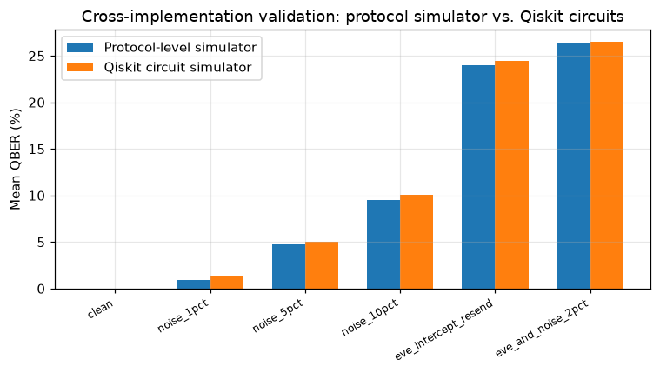
Fig. 22. Mean QBER by condition, protocol-level simulator vs. Qiskit circuit simulator. The two independent implementations agree closely across all six conditions.
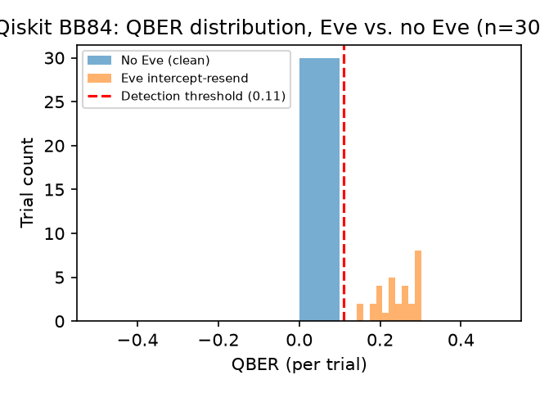
Fig. 23. Qiskit circuit simulator: per-trial QBER distribution with and without an intercept-resend eavesdropper (n=30 each), against the 0.11 detection threshold.
The two independent implementations agree closely (largest absolute difference 0.62 percentage points, comparing 200-bit against 2000-bit per-trial samples), and the Qiskit implementation likewise detected the intercept-resend eavesdropper in 30 of 30 trials at the same 0.11 QBER threshold. This is cross-implementation validation that the protocol-level simulator's sifting and QBER-estimation logic correctly reproduces the behavior of explicit per-qubit state preparation and measurement circuits. It does not change BB84's status in this project: running these circuits on a classical simulator, or hypothetically on real quantum hardware, still transmits no physical photon and exercises no physical no-cloning property. BB84 in this project remains, in every implementation, a software simulation.
- Final Layer 2 Experiments: Optimized PQC Backend, End-to-End Security and BB84 Statistics
- Reference vs. Optimized PQC Implementation
Because native liboqs could not be built, the compiled pqcrypto package (version 1.0.0) was used as the optimized backend and compared with the pure-Python reference implementations under identical messages and parameter sets. Timing used a high-resolution monotonic timer with warm-up runs excluded; the number of repetitions differs by backend and is reported in Table. Speedup is an implementation-backend comparison, not a cryptographic advantage.
S = T_reference / T_optimized; R(%) = 100 * (T_reference - T_optimized) / T_reference (20)
TABLE VII
Reference Python vs. pqcrypto: median latency and speedup
Algorithm | Op. | n ref/opt | Ref. median (ms) | pqcrypto median (ms) | Speedup
ML-DSA-65 | keygen | 30/200 | 11.5 | 0.237 | 48.5x
ML-DSA-65 | sign | 30/200 | 45.5 | 9.45 | 4.8x
ML-DSA-65 | verify | 30/200 | 12.7 | 0.22 | 57.6x
ML-KEM-768 | decaps | 30/200 | 6.78 | 0.111 | 61.0x
ML-KEM-768 | encaps | 30/200 | 5.02 | 0.0876 | 57.3x
ML-KEM-768 | keygen | 30/200 | 3.71 | 0.0721 | 51.5x
SLH-DSA-SHA2-128f | keygen | 3/200 | 22.8 | 2.56 | 8.9x
SLH-DSA-SHA2-128f | sign | 3/200 | 231 | 60.2 | 3.8x
SLH-DSA-SHA2-128f | verify | 10/200 | 12.8 | 3.68 | 3.5x
SLH-DSA-SHA2-128s | keygen | 3/30 | 1.25e+03 | 163 | 7.7x
SLH-DSA-SHA2-128s | sign | 3/30 | 4.33e+03 | 1.27e+03 | 3.4x
SLH-DSA-SHA2-128s | verify | 10/200 | 4.42 | 1.23 | 3.6x
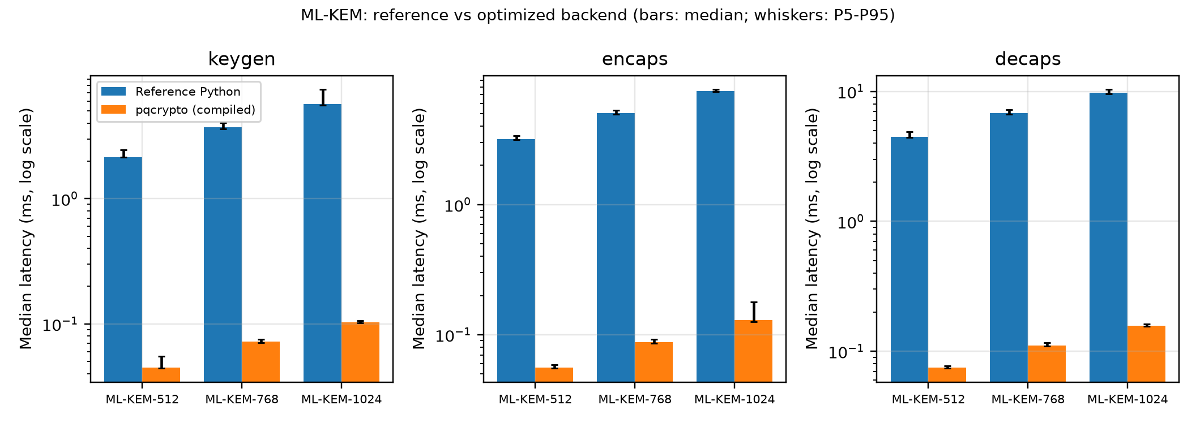
Fig. 24. ML-KEM key generation, encapsulation and decapsulation: reference Python vs. pqcrypto (log-scale latency; whiskers P5-P95).
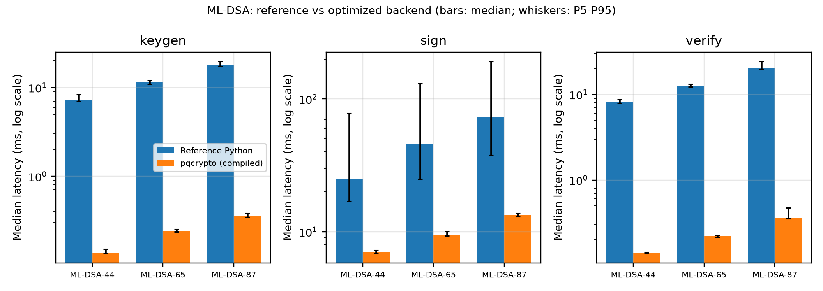
Fig. 25. ML-DSA key generation, signing and verification: reference vs. pqcrypto (log-scale latency).
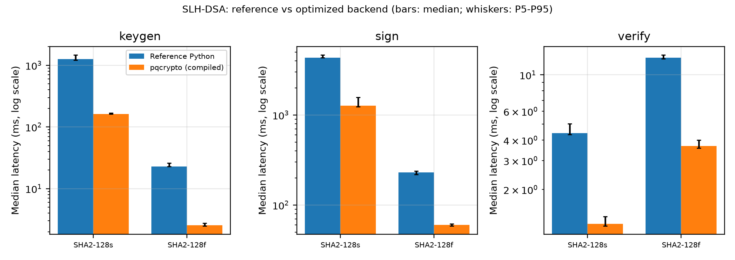
Fig. 26. SLH-DSA-SHA2-128s/128f: reference vs. pqcrypto (log-scale latency; reference signing n=3).
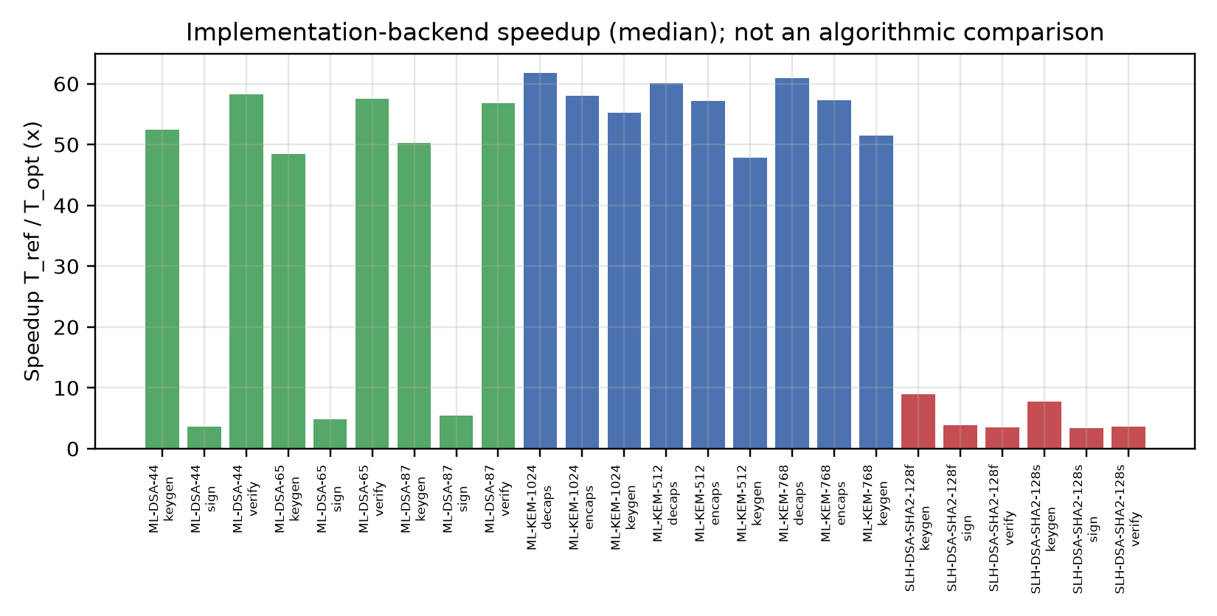
Fig. 27. Implementation-backend speedup by operation (median ratio); not an algorithmic comparison.
Speedups ranged from 3.4x to 61.8x. ML-KEM and ML-DSA key generation, encapsulation/decapsulation and verification were roughly 50-60x faster compiled, whereas ML-DSA signing (rejection sampling) improved by 4.8x. For SLH-DSA-SHA2-128s signing the reference median in this controlled run was 4.33 s (n=3) against 1.27 s (n=30) for pqcrypto, a 3.4x difference. The earlier ~15 s reference observation (n=5) is preserved as reference-implementation history; it is not reproduced by this controlled run, so no implementation-independent SLH-DSA latency is claimed. Because compiled SLH-DSA-128s signing remains about two orders of magnitude slower than compiled ML-DSA-65, its cost is mostly a property of the parameter set and only partly of the pure-Python implementation.
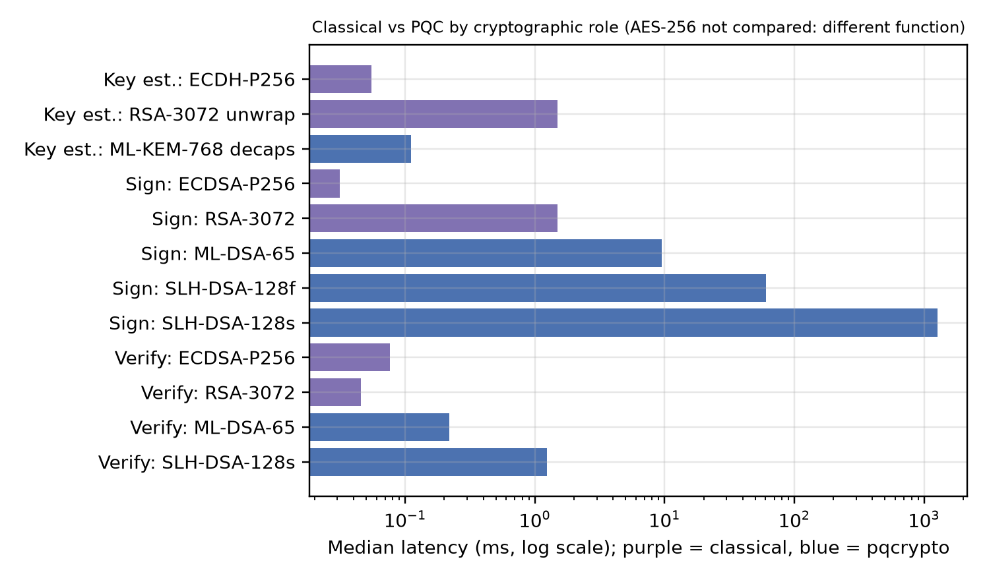
Fig. 28. Latency by cryptographic role: classical ECDH/ECDSA/RSA vs. pqcrypto ML-KEM/ML-DSA/SLH-DSA (AES-256 is not compared because it performs a different function).
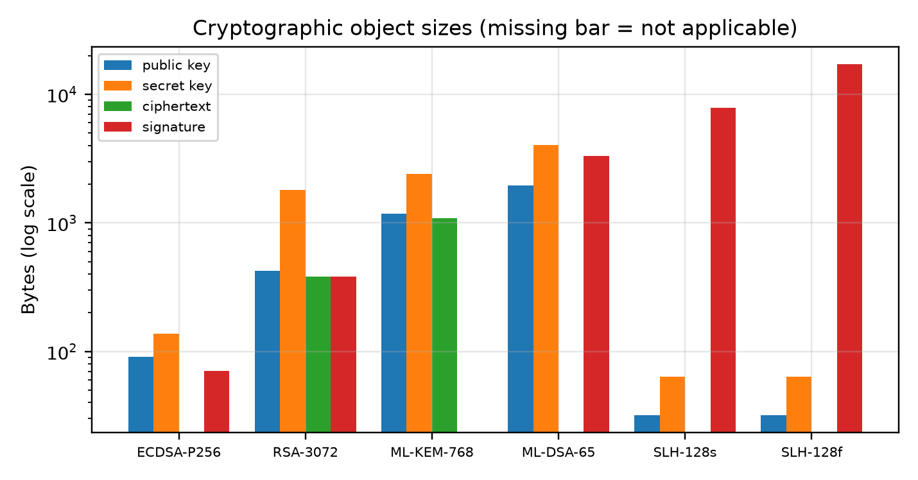
Fig. 29. Public-key, secret-key, ciphertext and signature sizes (log scale).
- End-to-End Banking Transaction Protection
A canonical JSON transaction is hashed, signed, protected with a session key (ECDH-P256 and/or ML-KEM-768 secrets combined by HKDF-SHA256) and AES-256-GCM, passed in memory (no network latency), decrypted and verified. Long-term public keys are assumed pre-distributed; KEM ciphertext/ephemeral-key and signature bytes count toward the secured payload.
TABLE VIII
End-to-end protection latency and payload expansion by configuration
Configuration | n | Median (ms) | P95 (ms) | Secured (B) | Expansion
A classical_ECDH+ECDSA | 200 | 0.302 | 0.568 | 475 | 1.5x
B reference_ML-KEM-768+ML-DSA-65 | 30 | 72.8 | 141 | 4737 | 15.2x
C optimized_ML-KEM-768+ML-DSA-65 | 200 | 10.2 | 11 | 4737 | 15.2x
D hybrid_optimized_ECDH+ML-KEM-768_ECDSA+ML-DSA-65 | 200 | 10.5 | 11 | 4873 | 15.6x
B2 reference_ML-KEM-768+SLH-DSA-128s | 3 | 3.63e+03 | 3.66e+03 | 9284 | 29.8x
C2 optimized_ML-KEM-768+SLH-DSA-128s | 20 | 1.25e+03 | 1.27e+03 | 9284 | 29.8x
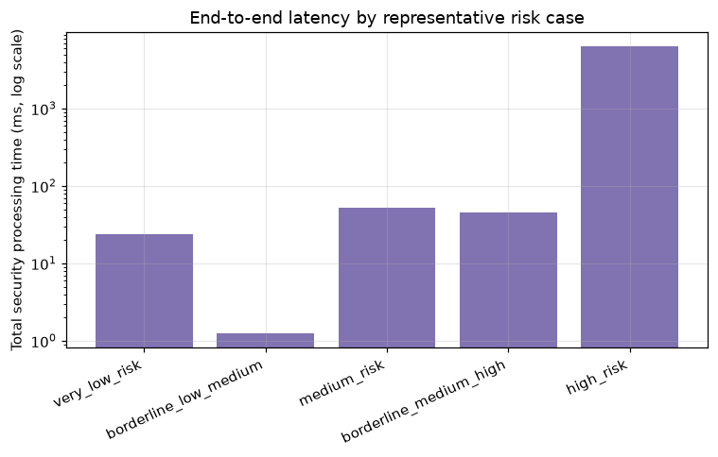
Fig. 30. End-to-end latency by configuration (log scale; whisker to P95).
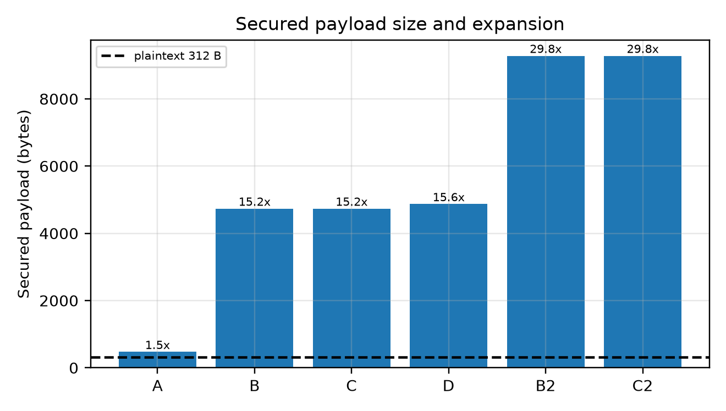
Fig. 31. Secured payload size and expansion relative to plaintext.
- BB84 Final Software Statistics and Eve-Detection Threshold
The protocol-level simulator (100 trials at 500 and 2000 transmitted bits) and the Qiskit/Aer circuit simulator (50 trials at 500 bits) were run over the same six conditions. QBER = N_error/N_sifted over the full sifted key. Comparing the two at 500 bits per trial gave MAE 0.0028, RMSE 0.0036 and a maximum absolute difference of 0.0065. The two noise models differ by construction, so this is a cross-check rather than an identity.
TABLE IX
BB84 software simulation results
Implementation | Condition | Trials | Mean QBER | 95% CI | Detect@0.11
protocol 2000 | clean | 100 | 0.0000 | [0.0000, 0.0000] | 0.00
protocol 2000 | noise_1pct | 100 | 0.0097 | [0.0091, 0.0103] | 0.00
protocol 2000 | noise_5pct | 100 | 0.0490 | [0.0477, 0.0504] | 0.00
protocol 2000 | noise_10pct | 100 | 0.0979 | [0.0960, 0.0999] | 0.12
protocol 2000 | eve_intercept_resend | 100 | 0.2508 | [0.2479, 0.2537] | 1.00
protocol 2000 | eve_and_noise_2pct | 100 | 0.2606 | [0.2578, 0.2635] | 1.00
qiskit 500 | clean | 50 | 0.0000 | [0.0000, 0.0000] | 0.00
qiskit 500 | noise_1pct | 50 | 0.0082 | [0.0059, 0.0104] | 0.00
qiskit 500 | noise_5pct | 50 | 0.0498 | [0.0458, 0.0538] | 0.00
qiskit 500 | noise_10pct | 50 | 0.0960 | [0.0896, 0.1023] | 0.22
qiskit 500 | eve_intercept_resend | 50 | 0.2438 | [0.2360, 0.2515] | 1.00
qiskit 500 | eve_and_noise_2pct | 50 | 0.2649 | [0.2576, 0.2722] | 1.00
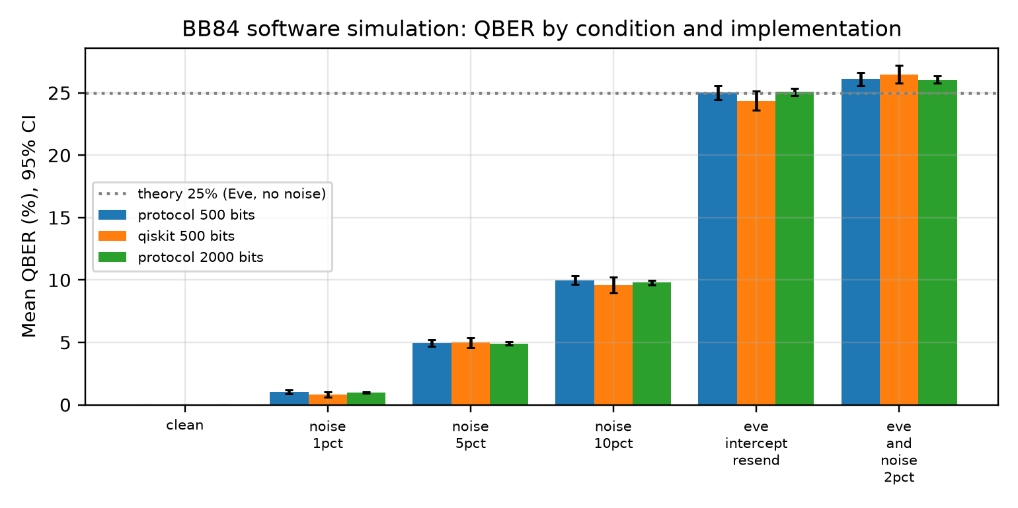
Fig. 32. Mean QBER with 95% confidence intervals by condition and implementation.
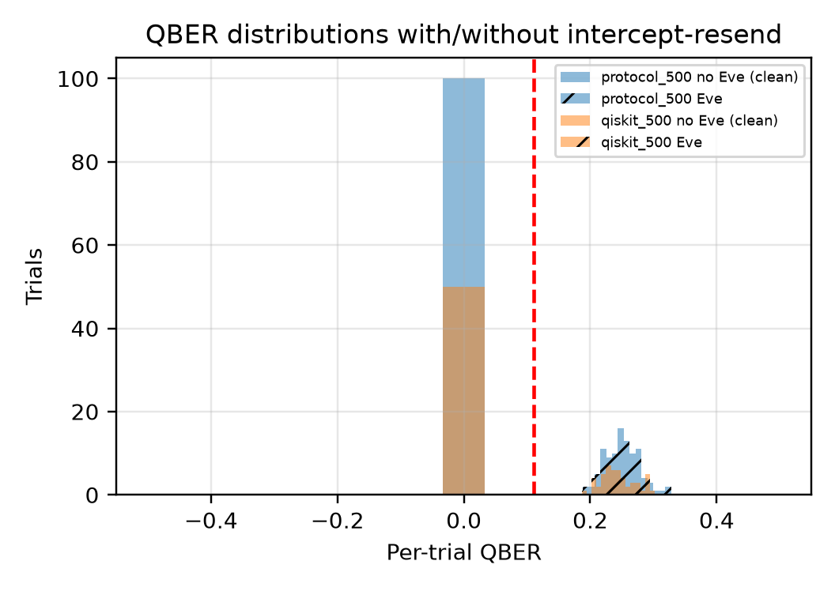
Fig. 33. Per-trial QBER distributions with and without intercept-resend (threshold 0.11 dashed).
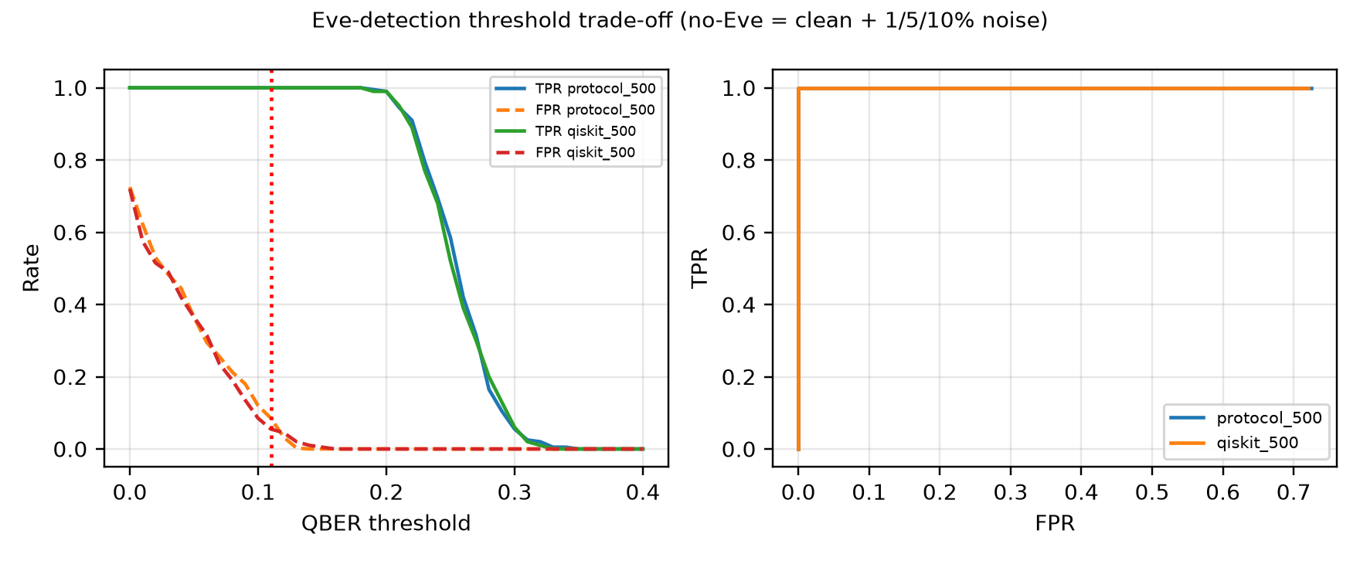
Fig. 34. Eve-detection threshold trade-off (TPR/FPR and ROC-style view).
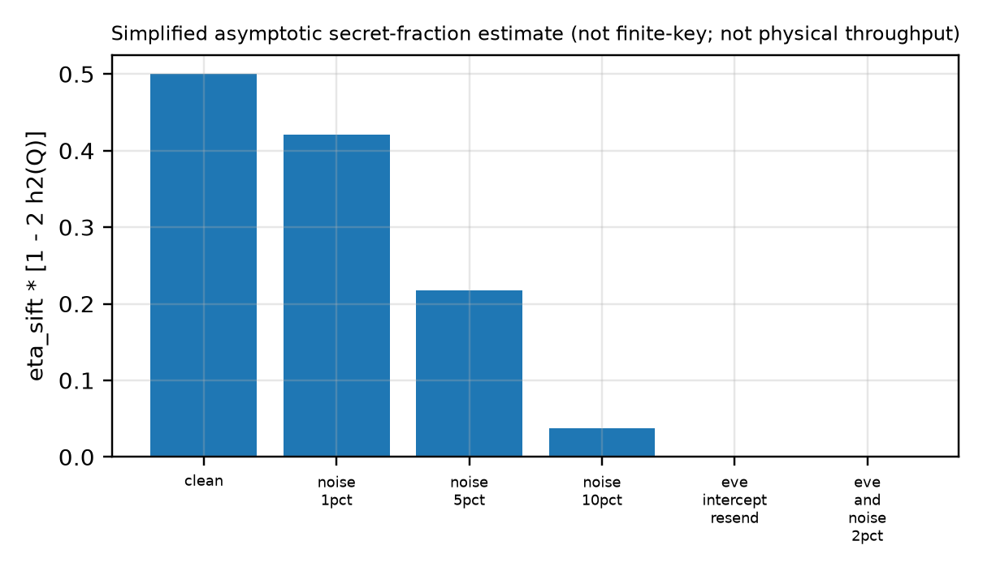
Fig. 35. Simplified asymptotic secret-fraction estimate (not a finite-key proof and not physical throughput).
At the conventional 0.11 threshold every Eve-present trial was flagged (TPR 1.00), but Eve-absent trials at 10% noise produced false alarms (FPR 0.030 for the 2000-bit protocol set). A higher threshold separates the classes in these simulated conditions, but that optimum depends on the chosen noise range. QBER above a threshold does not by itself prove an eavesdropper because channel noise also raises QBER.
- IBM Quantum Hardware Experimental Validation
Selected QSFD circuits were executed on IBM Quantum hardware. The first ibm_marrakesh job (db2u94vr11fs7397g1u0; 17 circuits, 1024 shots) is retained as a pilot baseline. The replicated campaign used ibm_marrakesh with 5 independent jobs (260 circuits, 532480 shots in total). Three physical qubits were chosen from the calibration snapshot before any run (best, median and 90th-percentile of readout-plus-single-qubit error), and the same 16 BB84 circuits (matched, mismatched and intercept-resend model) ran on each, together with a two-qubit Grover circuit at transpiler optimization levels 0-3 on the best-calibrated coupled pair. Ideal Aer and backend-derived noisy Aer controls used identical mappings. All five replicate jobs ran within one session, so temporal replication across calibration periods was not performed.
TABLE X
Theory vs. ideal Aer vs. noisy Aer vs. IBM hardware (mean over independent jobs)
Experiment | Qubit | Theory | Ideal Aer | Noisy Aer | IBM mean | 95% CI
BB84 matched-basis QBER (no Eve) | best (q98) | 0 | 0.0000 | 0.0025 | 0.0048 | [0.0036, 0.0060]
Intercept-resend QBER | best (q98) | 0.25 | 0.2500 | 0.2512 | 0.2632 | [0.2579, 0.2685]
BB84 matched-basis QBER (no Eve) | typical (q155) | 0 | 0.0000 | 0.0110 | 0.0094 | [0.0082, 0.0106]
Intercept-resend QBER | typical (q155) | 0.25 | 0.2500 | 0.2557 | 0.2591 | [0.2535, 0.2648]
BB84 matched-basis QBER (no Eve) | worse (q126) | 0 | 0.0000 | 0.0738 | 0.0446 | [0.0277, 0.0616]
Intercept-resend QBER | worse (q126) | 0.25 | 0.2500 | 0.2873 | 0.2868 | [0.2796, 0.2939]
Grover 2q success probability | pair [135, 139] | 1 | 1.0000 | 0.9678 | 0.9460 | [0.9386, 0.9534]
TABLE XI
Physical qubits used, calibration snapshot and observed hardware error
Role | Qubit | T1 (us) | T2 (us) | Readout err. | No-Eve QBER
best | 98 | 266 | 69 | 0.0021 | 0.0048
typical | 155 | 394 | 107 | 0.0122 | 0.0094
worse | 126 | 104 | 9 | 0.0759 | 0.0446
grover_pair | 135 | 295 | 91 | 0.0229
grover_pair | 139 | 136 | 159 | 0.0054
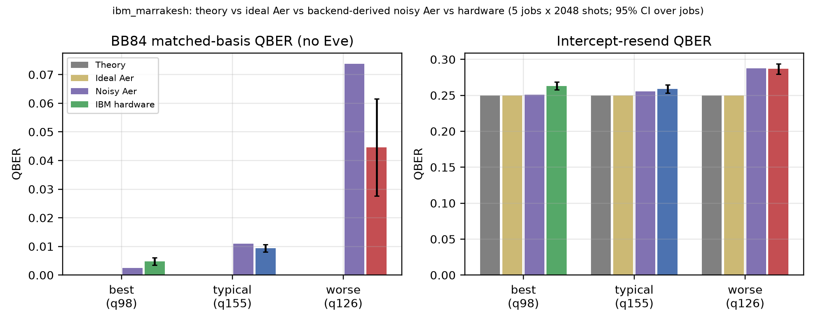
Fig. 36. BB84 QBER: theory vs. ideal Aer vs. noisy Aer vs. IBM hardware (ibm_marrakesh, 5 jobs).
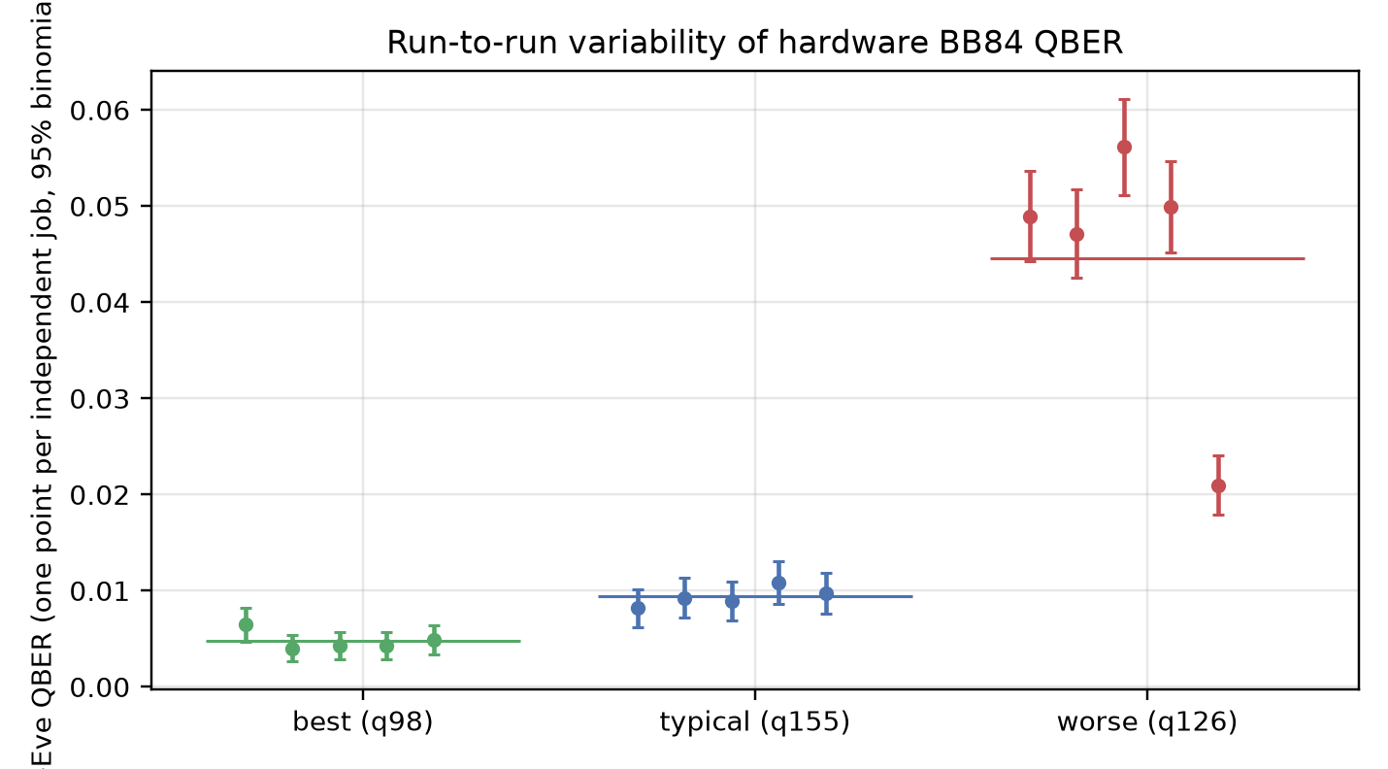
Fig. 37. Run-to-run variability: one point per independent hardware job with 95% binomial CI.
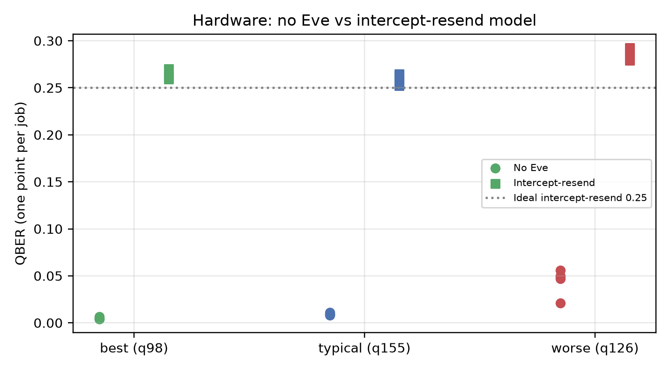
Fig. 38. Hardware no-Eve vs. intercept-resend-model QBER by job and qubit tier.
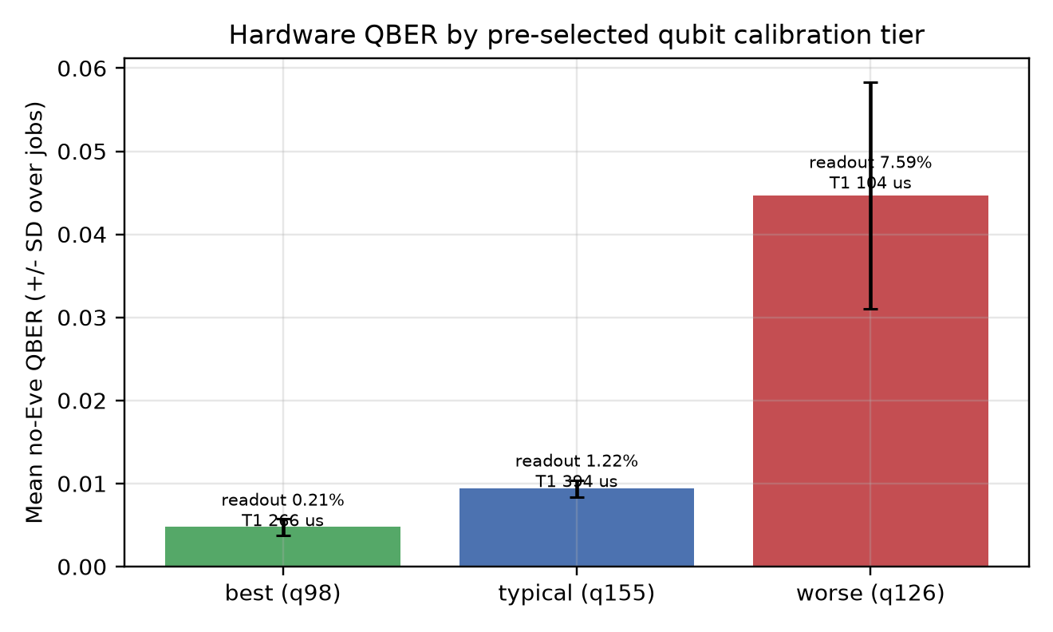
Fig. 39. No-Eve QBER by pre-selected calibration tier (three qubits; descriptive).
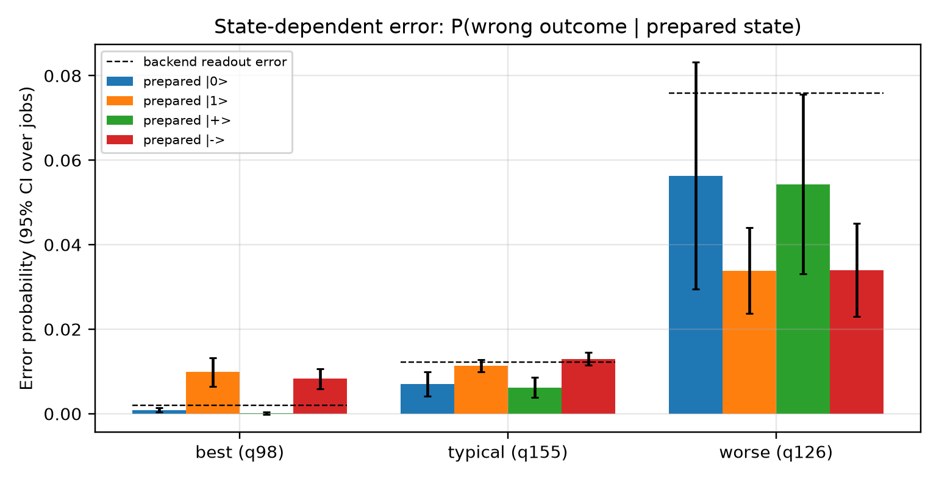
Fig. 40. State-dependent error probabilities against backend readout error.
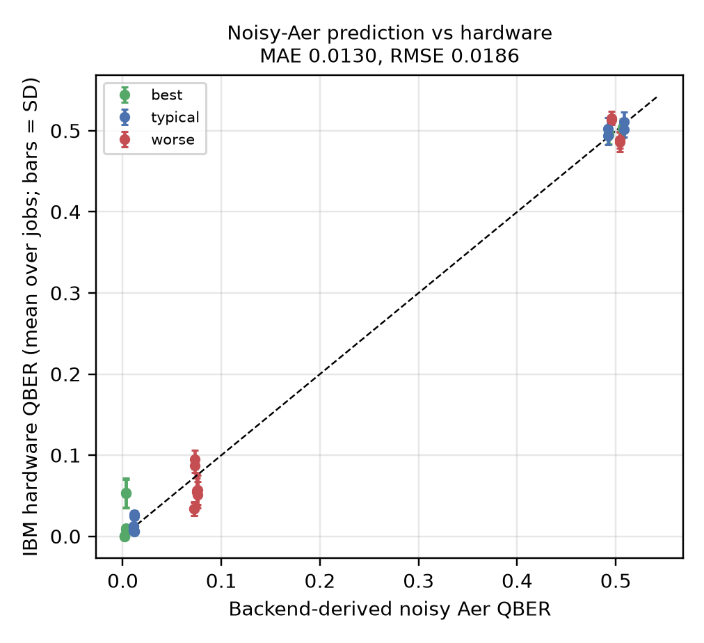
Fig. 41. Backend-derived noisy-Aer prediction vs. hardware QBER per circuit and qubit tier.
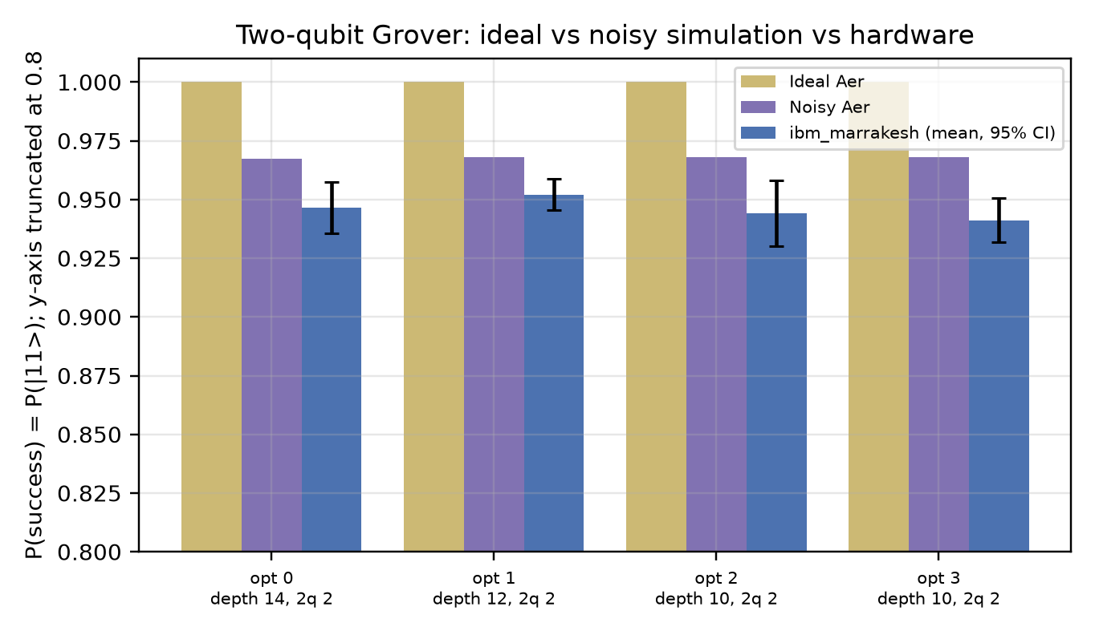
Fig. 42. Two-qubit Grover success probability: ideal Aer, noisy Aer and hardware by optimization level.
Eve vs. no-Eve: paired by job, the intercept-resend model raised hardware QBER by 0.2584 (best qubit, bootstrap CI [0.2558, 0.2615]), 0.2497 (typical) and 0.2422 (worse). Every one of the 15 job-by-qubit cells separated (maximum no-Eve QBER 0.0562 against minimum Eve QBER 0.2524). With five paired jobs the smallest attainable one-sided sign-flip p-value is 0.0312, so effect sizes and intervals carry the evidence. Hardware no-Eve QBER followed the calibration tier (0.0048, 0.0094, 0.0446). The |1>-misread asymmetry seen in the pilot held in 11/15 job-by-qubit cells and reversed on the worse qubit, so it is qubit-dependent; it is consistent with relaxation and asymmetric readout effects but no unique cause is established. Backend-derived noisy Aer predicted hardware with MAE 0.0130 (ideal Aer: 0.0218), but over-predicted error on the worse qubit; the noise model used backend properties at analysis time. The Grover circuit succeeded with pooled probability 0.9460 on hardware; optimization-level differences were small compared with between-job variation. An earlier ibm_fez job (da6ejl46l22c73dm82ng) executed the CLT-QNN and linear-QNN circuits with frozen simulator-trained weights on six held-out transactions; hardware outputs deviated from simulation by a mean absolute 0.229 (CLT) and 0.417 (linear), supporting physical executability only.
These runs validate selected circuit-level components. They are not physical quantum key distribution (no photons or communicating parties), they do not execute the full fraud classifier, they depend on backend, calibration, mapping and execution time, Shor's algorithm is not implemented, and the small Grover circuit has no implication for AES or RSA key sizes.
- Layer 1-to-Layer 2 Integration
The refined architectural conclusion of this study is that fraud risk and cryptographic-quantum-risk posture must be modeled as separate axes rather than one derived from the other.
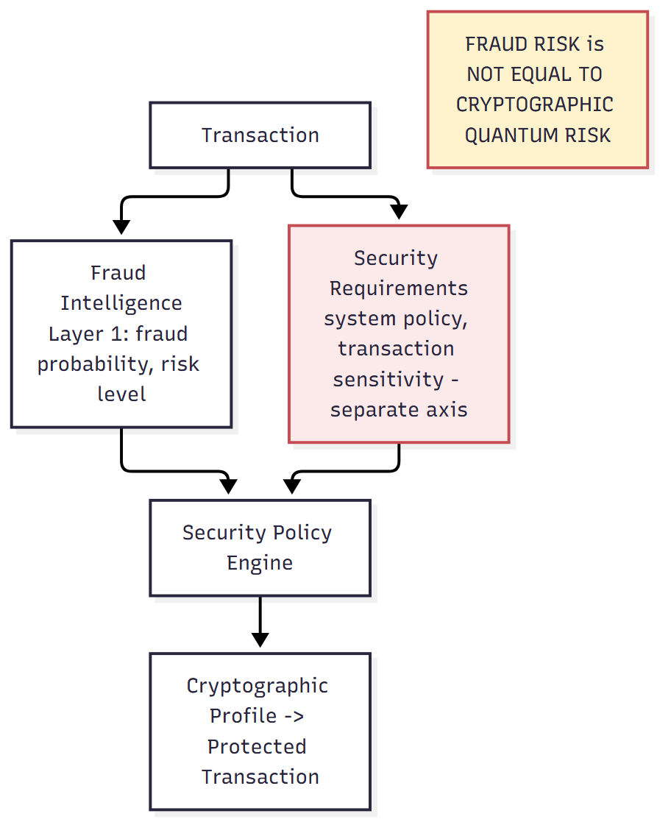
Fig. 43. Refined architecture separating fraud intelligence from security requirements before the security policy engine -- the key systems-level insight of this study.
TABLE XII
Routing Policy Ablation (Production Test Fold, n=55,133)
policy | security_escalation_rate | fraud_weighted_coverage | benign_escalation_rate
A_categorical | 0.0011 | 0.7432 | 0.0001
B_continuous | 0.0011 | 0.7432 | 0.0001
C_anomaly_assisted | 0.0015 | 0.7432 | 0.0005
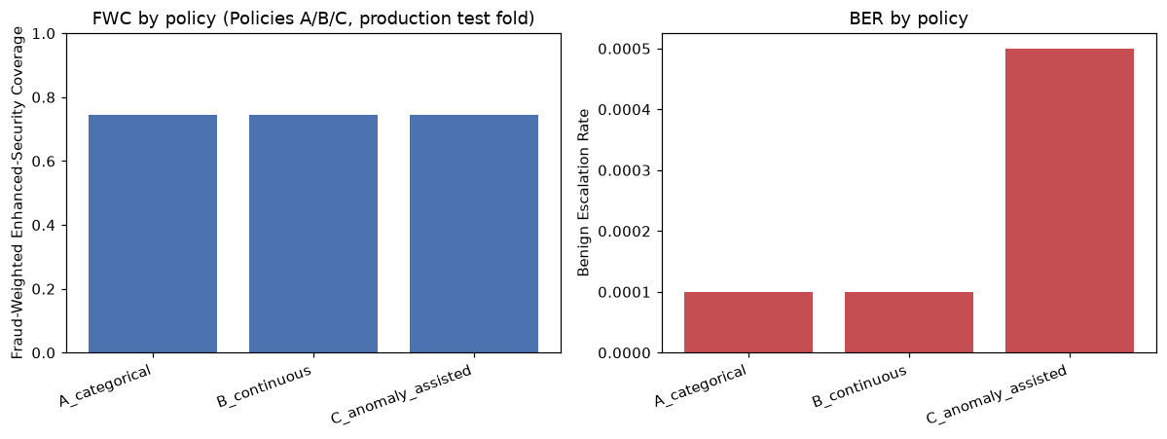
Fig. 44. Fraud-Weighted Enhanced-Security Coverage (left) and Benign Escalation Rate (right) by policy. Categorical and continuous routing are behaviorally identical; anomaly-assisted routing adds cost without adding coverage.
SER = N_escalated / N_total (15)
FWC = N_fraud,escalated / N_fraud,total (16)
BER = N_legit,escalated / N_legit,total (17)
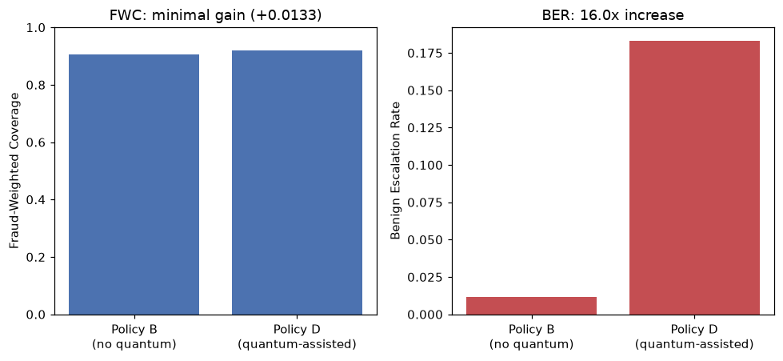
Fig. 45. Quantum-assisted routing (Policy D) vs. continuous routing alone (Policy B), on the separate locked confirmation sample. Coverage gain is marginal; benign-escalation cost is severe.
Categorical and continuous routing produced behaviorally identical results on this dataset. Anomaly-assisted routing added no additional fraud coverage while increasing benign escalation approximately fivefold. Quantum-assisted routing, evaluated on its own appropriately scoped sample, increased fraud coverage by only 1.33 percentage points (1 additional fraud case) while increasing benign escalation by a factor of 16.0, decisively failing the pre-specified cost budget for this experiment. Adding more sophisticated risk signals does not automatically improve security orchestration -- rejecting a signal that costs more than it is worth is the correct systems decision, and the pre-specified protocol is what makes this conclusion credible rather than post-hoc.
- Research Question Summary
TABLE XIII
Research Questions, Findings, and Interpretation
Research Question | Finding | Interpretation
Does Local-Sum improve Global QNN? | SUPPORTED | 20-seed paired bootstrap/Wilcoxon/permutation
Does quantum beat XGBoost? | NOT SUPPORTED | 95% CI crosses zero
Does quantum give verified incremental utility? | NOT VERIFIED | Classical control performs as well or better
Can PQC be integrated? | YES | Implemented, tested, benchmarked
What overhead does PQC introduce? | Substantial, implementation-dependent | Up to ~15s/signature (SLH-DSA, pure Python)
Does BB84 reproduce expected behavior? | YES, under stated conditions | 30/30 Eve detections
Does quantum/anomaly-assisted routing help under the cost budget? | NOT SUPPORTED | Fails pre-specified budget by 5-16x
Architectural lesson? | Fraud risk != cryptographic risk | Must be modeled as separate axes
- Scientific Contribution
TABLE XIV
Scientific Contribution Matrix
Contribution | Evidence | Establishes | Does Not Establish
Empirical QML | 20 paired seeds + CI/tests | Observable design improves matched QNN | QNN superiority over XGBoost
QML boundary | Classical capacity control | Improved QML != quantum predictive advantage | That quantum design never helps
Research methodology | Pre-specified protocols, negative-result preservation | A disciplined framework resistant to overclaiming | N/A
PQC system evaluation | Real implementations, 30-rep benchmarks; native liboqs backend attempted | Integration feasibility + real reference-implementation cost | Universal algorithm performance (native backend unavailable here)
QKD simulation + cross-validation | 180 protocol-simulator trials + 180 Qiskit circuit trials, 6 matched conditions | Expected simulator behavior reproduced by two independent implementations | Physical QKD security
Integrated systems insight | Pre-specified routing ablation | Fraud risk != cryptographic risk | Risk-adaptive security is universally ineffective
This study's contribution is not claimed as the first system to combine fraud detection with post-quantum or quantum-key-distribution research; it is methodological -- a statistically rigorous, pre-specified, and negative-result-preserving investigation connecting quantum circuit design, classical machine learning, standardized post-quantum cryptography, and simulated quantum-key distribution as sequential decision layers.
- Negative Results
TABLE XV
Negative and Null Results
Hypothesis | Result
Quantum beats classical baselines standalone | Rejected on identical controlled subset
Chow-Liu structure universally beats generic topology | Qubit-count dependent; open question
QBoost beats classical boosting | Rejected, both solvers
Hybrid fusion beats XGBoost alone | Rejected, all five architectures
Quantum anomaly detector beats classical anomaly detection | Reversed at larger scale
Data re-uploading improves QNN | No improvement, worse variance
Near-zero initialization improves QNN | Underperformed existing default
Local-Sum QNN beats XGBoost / classical control | Rejected, both comparisons
Categorical routing differs from continuous routing | Identical on tested dataset
Anomaly/quantum-assisted routing improves Layer 2 | Fails pre-specified cost budget
Native liboqs PQC backend installable in this environment | Unavailable -- no C/CMake toolchain
SLH-DSA cost is mostly a pure-Python artifact | Only partly: compiled SLH-DSA-128s signing still ~1.3 s, ~100x compiled ML-DSA-65
IBM hardware asymmetry |1> > |0> error is universal | Qubit-dependent: reversed on the worse-calibrated qubit
Each entry above narrowed the research question rather than ending it: rejecting a hypothesis under stronger validation is what allowed the Local-Sum observable finding, and the integration experiment's cost-budget rejections, to be trusted as genuine rather than a product of insufficiently rigorous testing.
- Threats to Validity and Limitations
Quantum experiments operate on a small, rebalanced controlled subset relative to the full production dataset. Post-quantum benchmarks reflect a pure-Python implementation, not a production-grade native library -- a native `liboqs` backend was attempted and found unavailable in this environment (no C/CMake toolchain) -- and should not be generalized as representative of deployed system performance. The Qiskit BB84 cross-validation used a reduced per-trial bit count (200 vs. 2000) to bound simulator overhead. No web dashboard, API layer, or concurrency/load testing exists. The integration experiment's null and negative findings were measured on a single dataset and threshold configuration. One of the three supplied project reference documents could not be read due to being a scanned, image-only file.
- Future Work: Layer 3
A third layer, addressing classical attacks (man-in-the-middle, replay, brute-force, adversarial machine-learning evasion and poisoning) and quantum attacks (Shor's and Grover's algorithms), remains unimplemented future work. No claim is made in this study that real-world RSA, ECC, or AES have been broken; any future demonstration of Shor's or Grover's algorithms would necessarily operate on illustrative, non-production key sizes.
- Conclusion
This study demonstrates that quantum model architecture can materially affect fraud-detection performance: the local-sum observable produced a statistically supported improvement over the matched global-observable QNN, replicated across 20 paired seeds. However, a strong classical capacity control shows that this improvement does not constitute a verified system-level quantum predictive advantage. In the security layer, standardized post-quantum primitives were successfully integrated with transaction protection but introduce implementation-dependent computational and communication overhead, while the BB84 simulator reproduces expected eavesdropping behavior under controlled conditions. Risk-routing experiments further show that additional quantum- or anomaly-derived signals do not automatically justify their operational cost under a pre-specified budget. Together, these findings identify both useful roles and practical boundaries for quantum technologies within a fraud-aware financial security architecture, and establish, as a central systems-level lesson, that fraud risk and cryptographic quantum risk must be treated as separate architectural concerns.
- References
- Pérez-Salinas, A., Cervera-Lierta, A., Gil-Fuster, E., & Latorre, J. I. (2020). Data re-uploading for a
- Grant, E., Wossnig, L., Ostaszewski, M., & Benedetti, M. (2019). An initialization strategy for addressing
- Cerezo, M., Sone, A., Volkoff, T., Cincio, L., & Coles, P. J. (2021). Cost function dependent barren plateaus
- Kyriienko, O., & Magnusson, E. B. (2022). Unsupervised quantum machine learning for fraud detection.
- (Project-supplied reference paper) Toward Practical Quantum Machine Learning: A Novel Hybrid Quantum LSTM for
- National Institute of Standards and Technology. (2024). FIPS 203: Module-Lattice-Based Key-Encapsulation
- National Institute of Standards and Technology. (2024). FIPS 204: Module-Lattice-Based Digital Signature
- National Institute of Standards and Technology. (2024). FIPS 205: Stateless Hash-Based Digital Signature
- Bennett, C. H., & Brassard, G. (1984). Quantum cryptography: Public key distribution and coin tossing.
- Pope, G. Kyber-py (pure-Python ML-KEM implementation). https://github.com/GiacomoPope/kyber-py
- Pope, G. Dilithium-py (pure-Python ML-DSA implementation). https://github.com/GiacomoPope/dilithium-py
- Xu, C. SLH-DSA (pure-Python SLH-DSA implementation). https://github.com/colinxu2020/slhdsa
- Quantum-secure Financial Platform (project pitch document, supplied by the user).
- Quantum_Secure_Fraud_Detection_System_SRS (project SRS, authored by Shreyansh Jaiswal, Abhishek Chaubey,
- Github repos 7th Sem Project (project reference-repository document) — unreadable in every supplied copy

